**A PROJECT REPORT**

**On**

**INTERIOR DESIGN WEBSITE**

**BE-III Semester**

**In**

**INFORMATION TECHNOLOGY**

**By**

**BUDARAPU NAVYA SRI (160121737147)**

**Under the guidance of**

**Sri Saketh Kallepu**



**DEPARTMENT OF INFORMATION TECHNOLOGY**

**CHAITANYA BHARATHI INSTITUTE OF TECHNOLOGY (A)**

**(Affiliated to Osmania University; Accredited by NBA(AICTE) and NAAC(UGC), ISO Certified 9001:2015)**

**GANDIPET, HYDERABAD – 500 075**

**Website:** [**www.cbit.ac.in**](http://www.cbit.ac.in)

**2022-2023**

**ACKNOWLEDGEMENT**

It is our privilege to acknowledge with deep sense of gratitude and devotion for keen personal interest and invaluable guidance rendered by our Project Guide **Sri Saketh Kallepu**.

We are grateful to our Principal **Dr. P. Ravinder Reddy**. Chaitanya Bharathi Institute of Technology, for his cooperation and encouragement.

Finally, we also thank all the faculty of Dept. of IT, CBIT, our friends, and all our family members who with their valuable suggestions and support, directly or indirectly helped us in completing this project work.

**CHAITANYA BHARATHI INSTITUTE OF TECHNOLOGY (A)**

DEPARTMENT OF INFORMATION TECHNOLOGY

**(Affiliated to Osmania University)**

**GANDIPET, HYDERABAD – 500 075**



**CERTIFICATE**

This isto certify that the project work entitled “**Interior Design Website**” submitted to CODEGNAN**,** in partial fulfilment of the requirements for the award of the completion of Front-End Web Development internship III semester of B.E in Information Technology, during the academic year 2022-2023, is a record of original work done by **Budarapu Navya Sri (160121737147)** during the period of study in Department of IT, CBIT, HYDERABAD, under our supervision and guidance.

**Project Guide**  **Head of the Department**

**Sri Saketh Kallepu Dr. K. Radhika**

Professor, Dept. of IT,

CBIT, Hyderabad.

**ABSTRACT:**

The project aims to design a website for Interior Design websites. This website will feature a modern, user-friendly design that allows customers to easily browse the Interior Designs. This is achieved through the use of HTML, CSS and JavaScript. This website will be designed to be visually appealing and highly functional. We have multiple options like Home, Book Online, About, Contact and log In. The website has the desktop and mobile view. This website shows the services and also the cost of the design. The goal is to create a delightful online experience that encourages the reader to create a blog and share their experience.

**CONTENTS**

**1. INTRODUCTION:**

**Interior design** is the art and science of enhancing the interior of a building to achieve a healthier and more aesthetically pleasing environment for the people using the space. An **interior designer** is someone who plans, researches, coordinates, and manages such enhancement projects. Interior design is a multifaceted profession that includes conceptual development, space planning, site inspections, programming, research, communicating with the stakeholders of a project, construction management, and execution of the design**.**

* 1. **MOTIVATION:**

To provide a clean and neat website for the interior designs. With a successful design of the interior design website, we can gain the complete knowledge of the prices and other things of the interior designs. More trendy and attractive designs are featured in this website.

* 1. **PROBLEM STATEMENT:**

There are many websites for the interior designs but there is no complete information about the designs so this website gives the complete and trendy designs for the user. The prices are not mentioned in many of the websites but in this website the prices are also mentioned. This website is easily accessible and easily used.

**2. EXISTING SYSTEM:**

In the existing system of interior design website, we have the pictures of the designs. In most of the websites, the cost of the design is not specified.

**3.PROPOSED SYSTEM:**

In the website we have designed the easily accessible and attractive designs. we can login into the website. We have the desktop and mobile view which is convenient to every user. We can access the Facebook, Twitter, LinkedIn through our website. When you click on My Services two options are available, home styling and commercial styling. The cost of each style is also specified. We can click on book now and check the availability. There is an option of contact, in which we can contact the interior designer. Moreover, the website is designed in eye-catchy way which is user-friendly.

**4.CODE AND IMPLEMENTATION:**

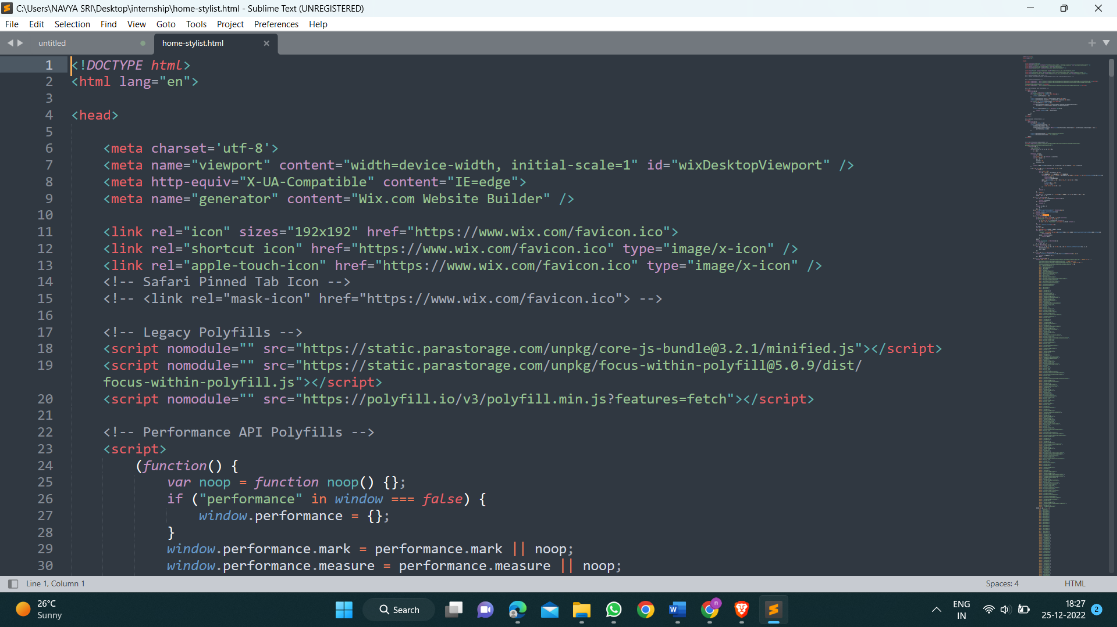

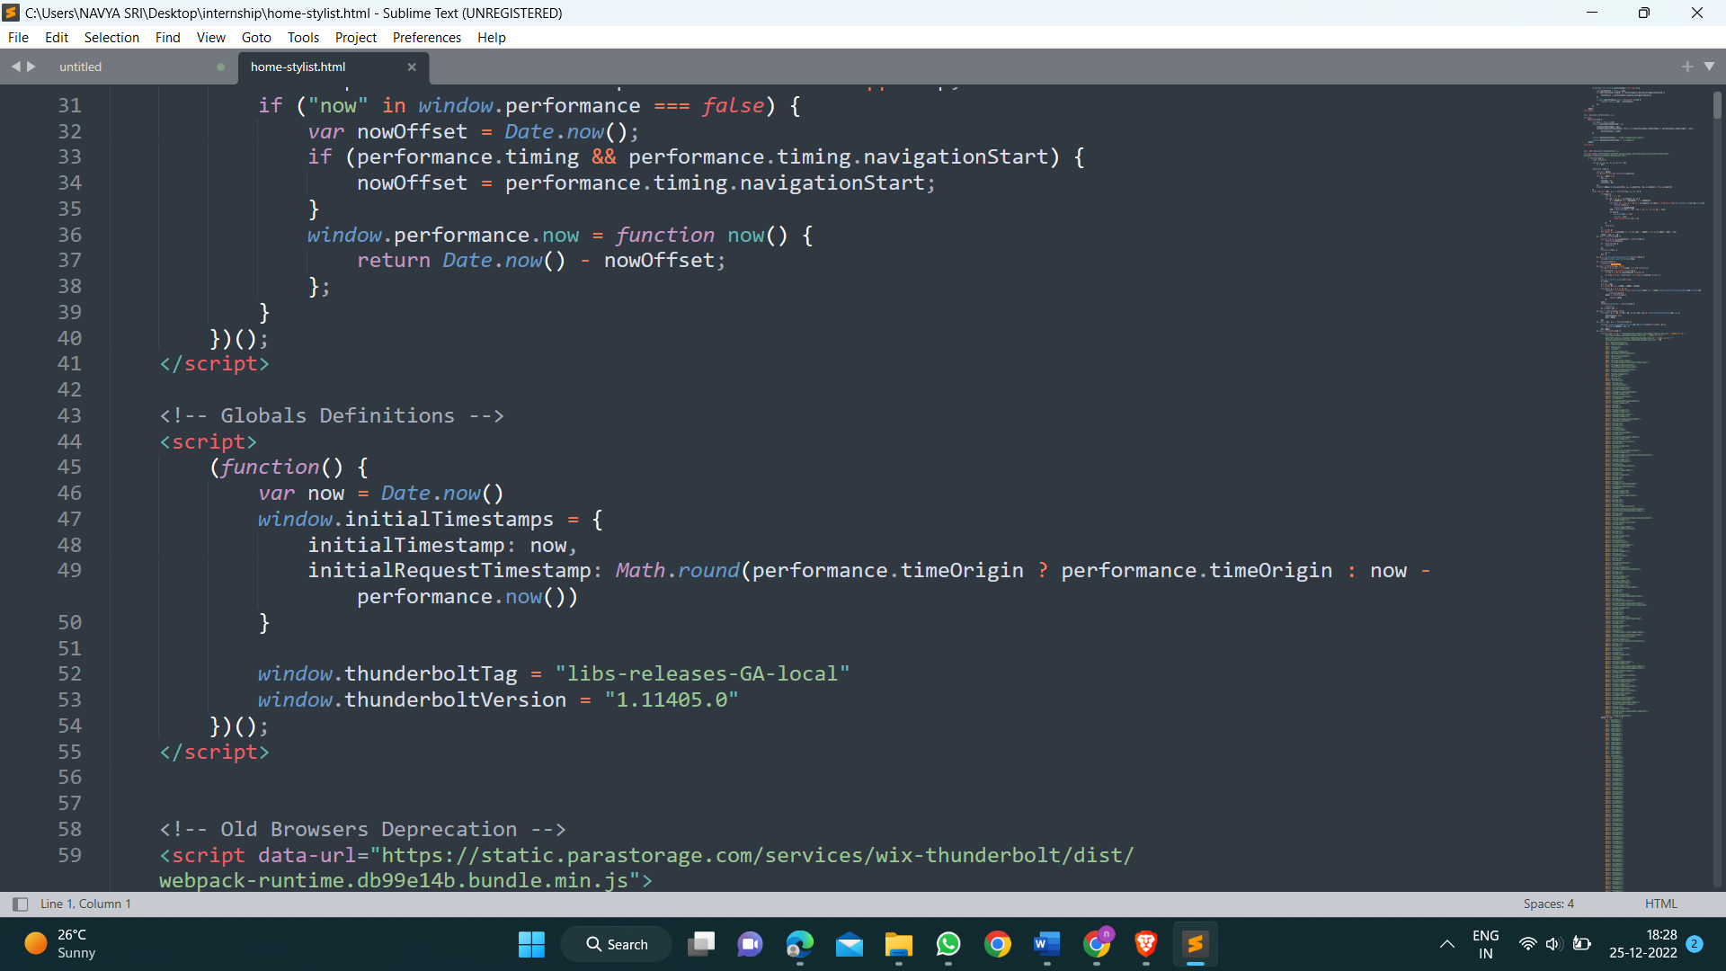

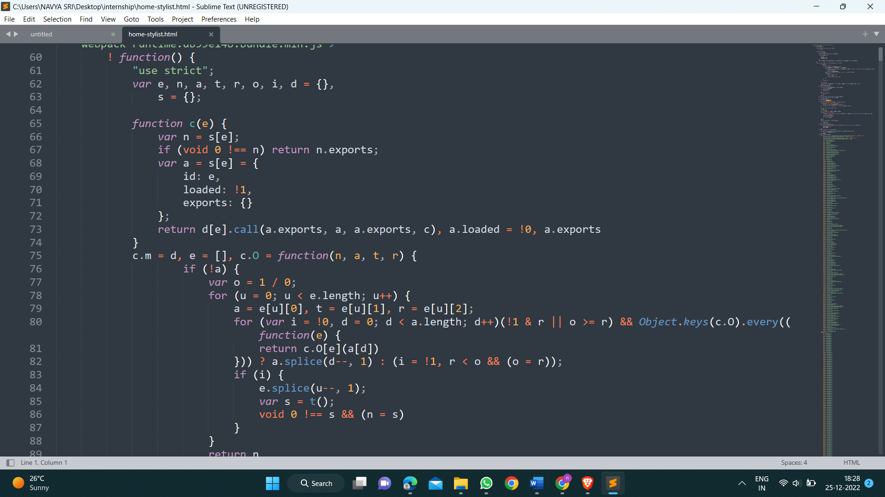

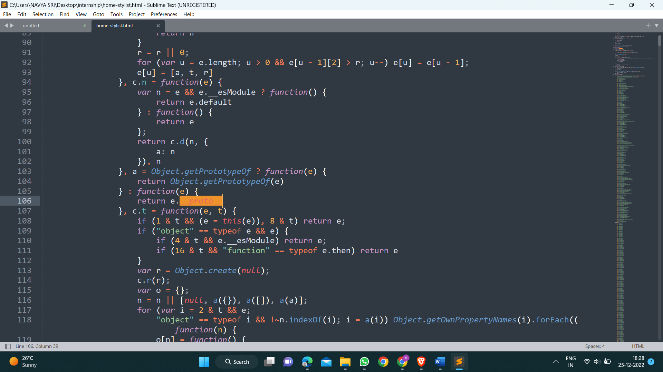

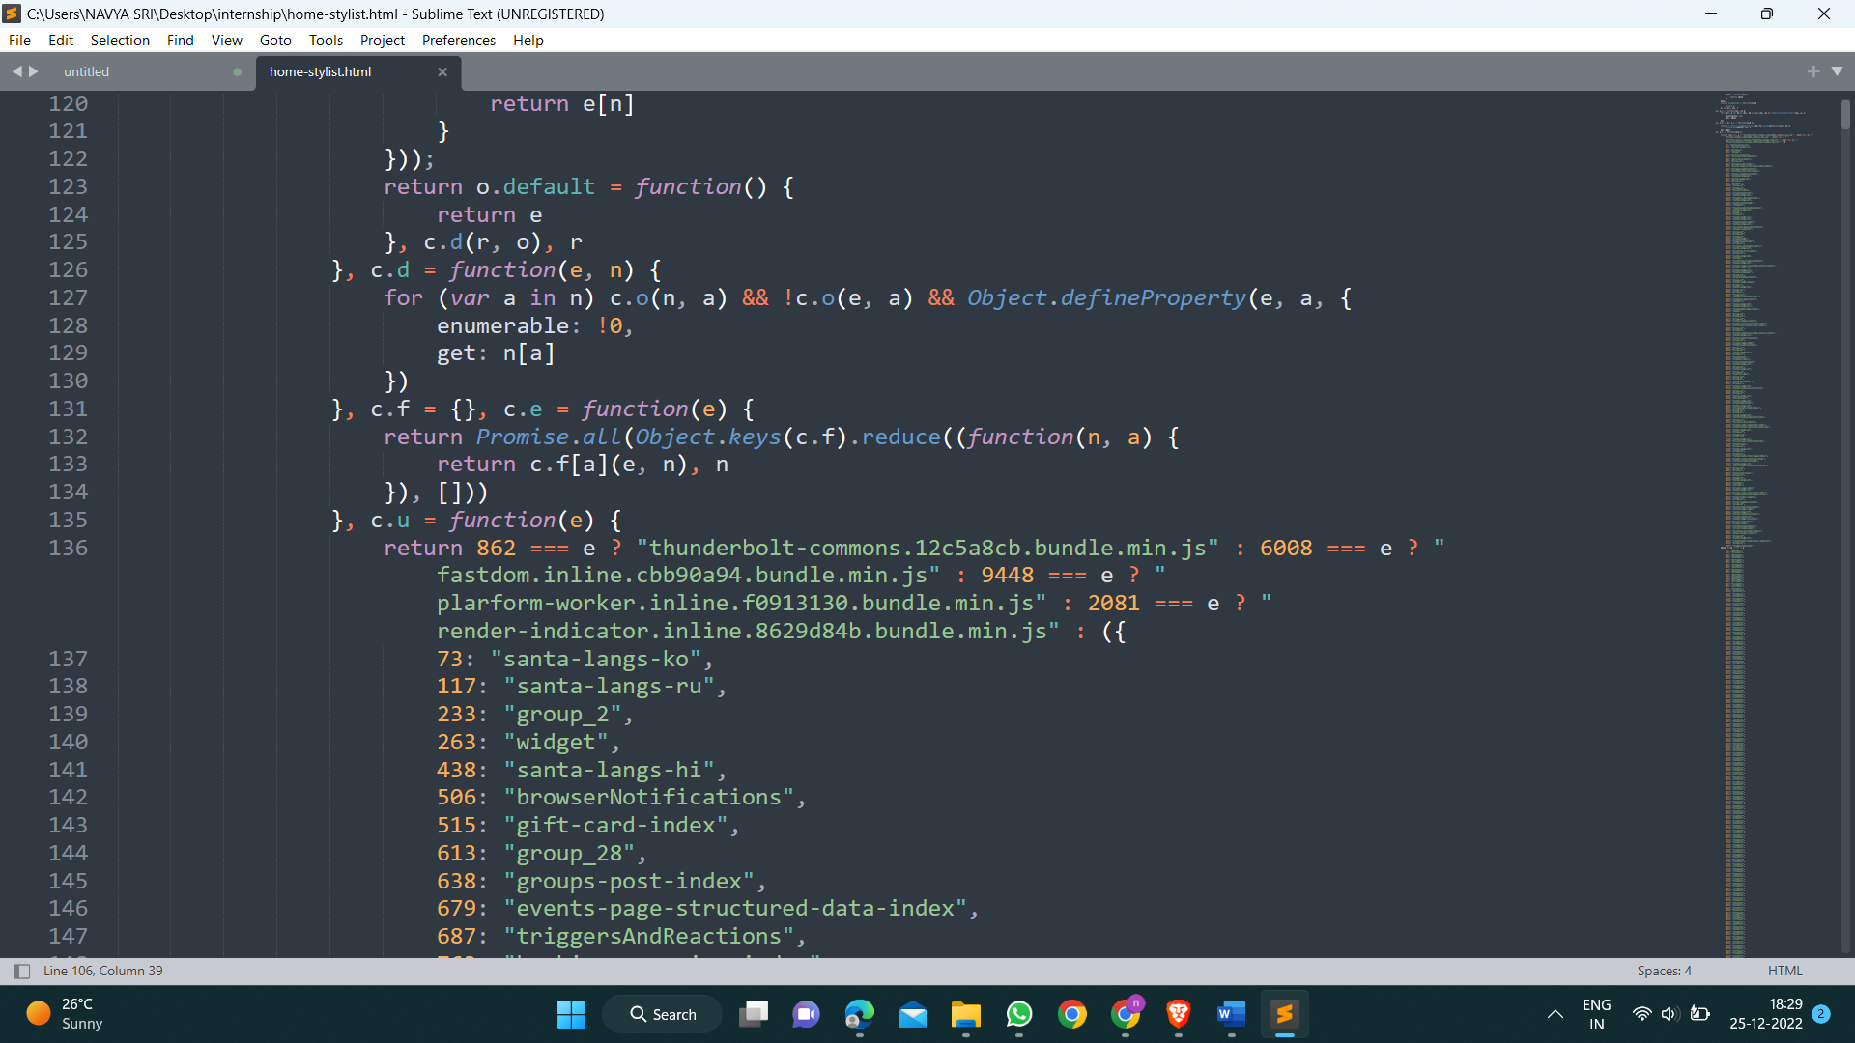 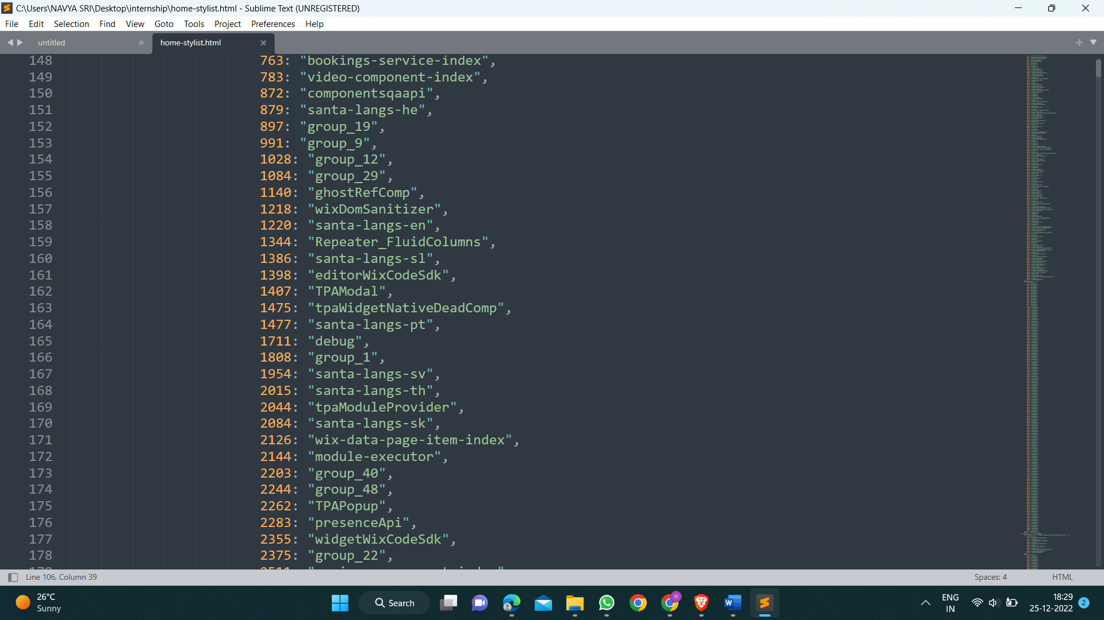 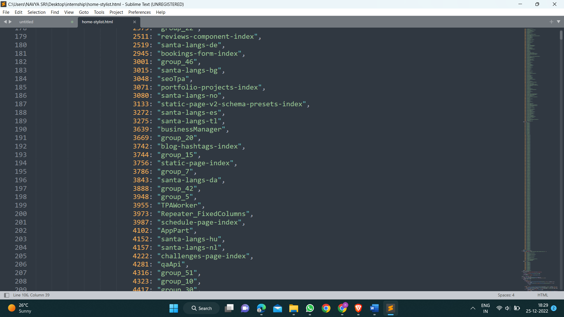 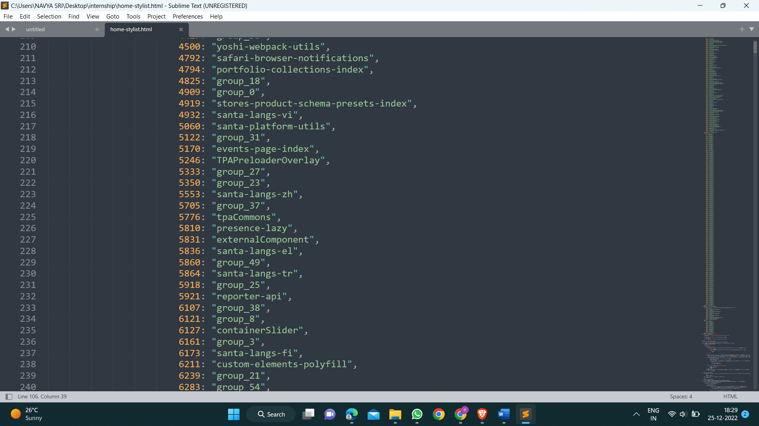 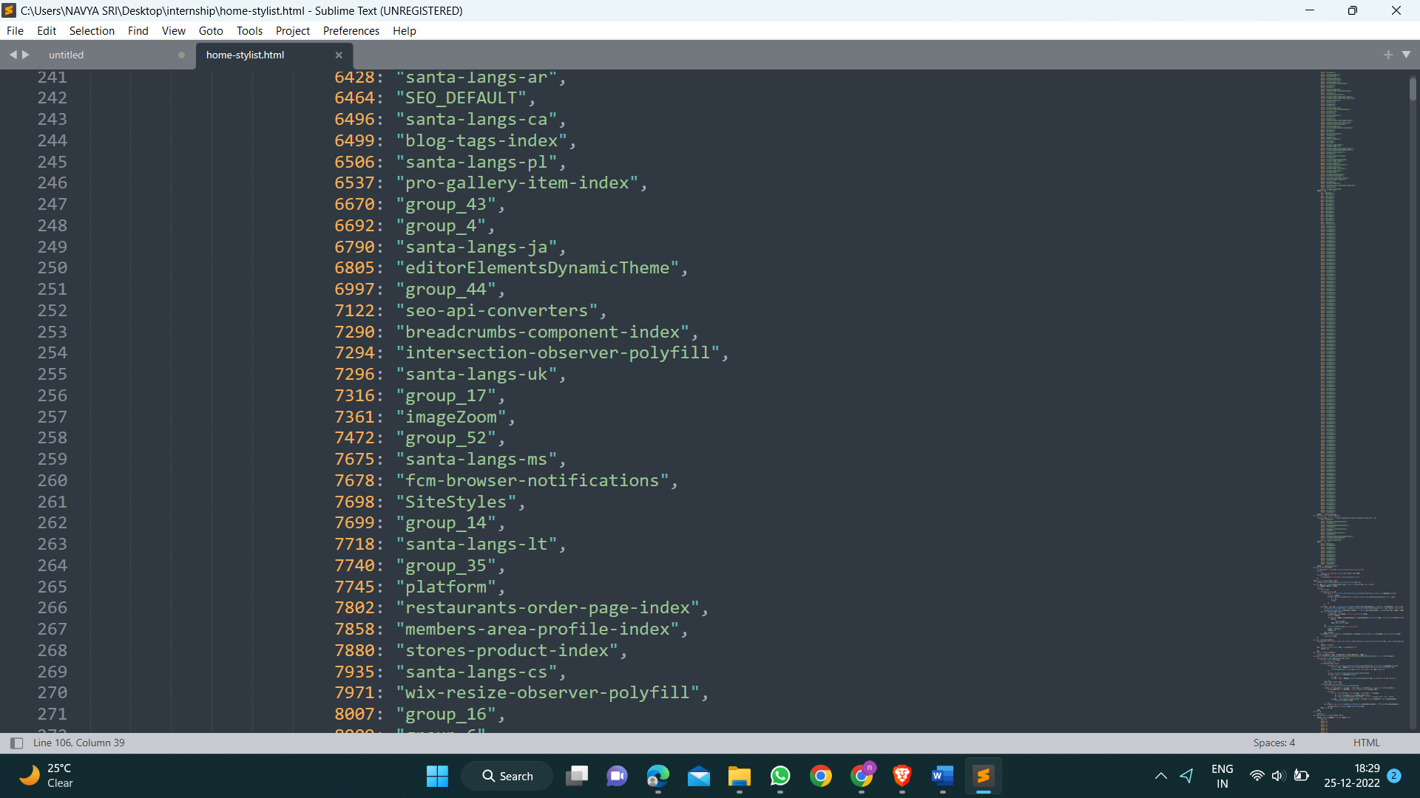 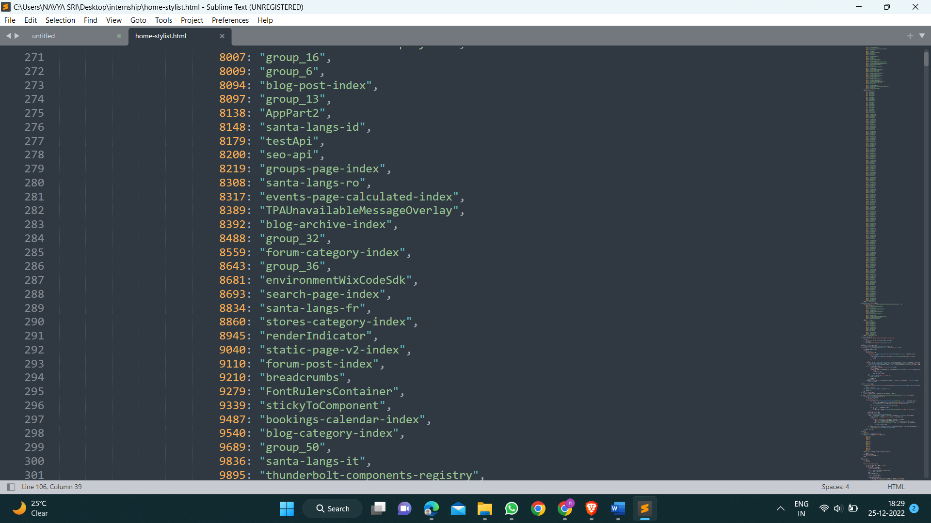 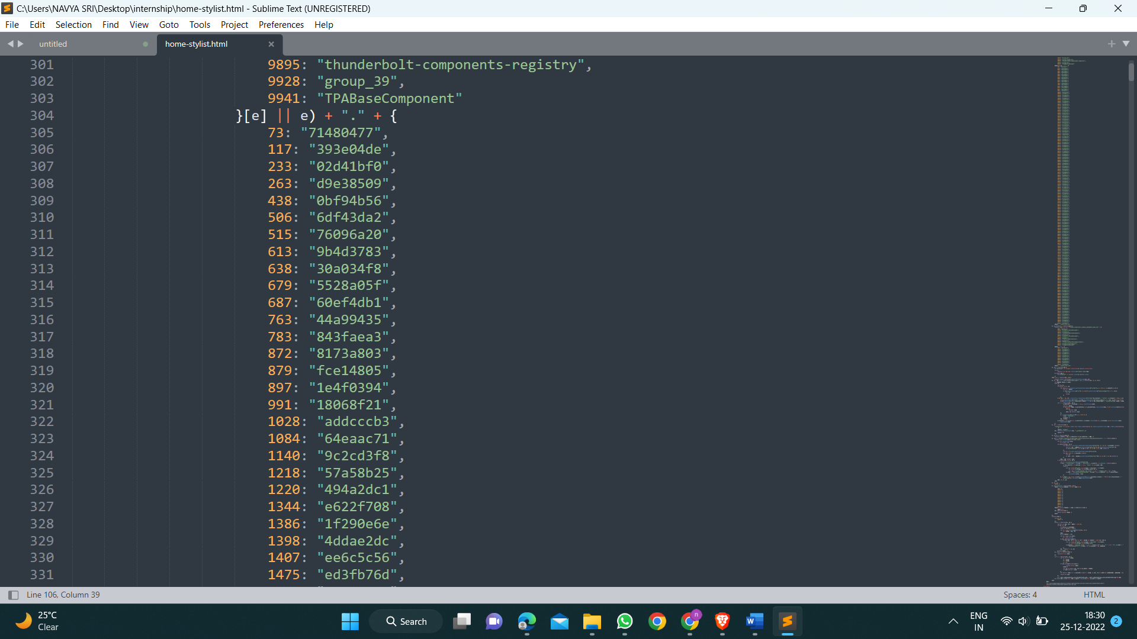 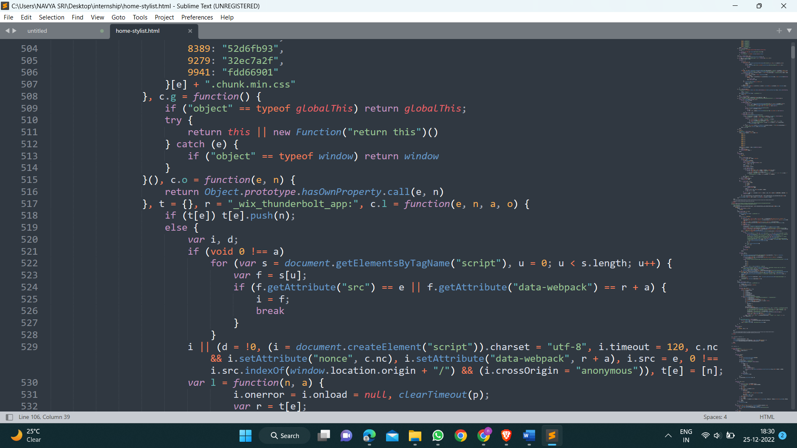

Code link :

C:\Users\NAVYA SRI\Desktop\internship\home-stylist.html

**5.CONCLUSION:**

***Interior*** ***design*** is an art form. Many people think that art is only displayed on tangible surfaces‚ such as paper or canvas. Any room an be turned into a work of art with a little creativity and imagination. Redesigning ***interiors*** is a career for many. ***Interior*** designers should be considered artists just as much as a painter or sculptor would. Designing ***interiors*** takes a lot more effort than just slapping some paint on the walls and rearranging furniture.